**Touch-less Face Recognition based Automatic Attendance System**

**Application Concept**

Every organization requires a robust and stable system to record the attendance of their staff member or students of school and college. And every organization have their own method to do so, some are taking attendance manually with a sheet of paper by calling their names during lecture hours and some have adopted biometrics system such as finger print etc or card based system.

But there is chance of card loss or unauthorized person may misuse the card for fake attendance. While in other biometrics such as finger print, iris or voice recognition, they all have their own flaws and also they are not 100% accurate Face recognition is more accurate and faster technique among other techniques and reduces chance of proxy attendance Face recognition involves two steps, first step involves the detection of faces and second step consist of identification of those detected face images with the existing database Our system uses face recognition approach to reduce the flaws of existing system with the help of machine learning, it requires a good quality camera to capture the images of staff member or students Touch-less Face recognition based Staff Attendance. In current times, a safe touch-less entry for your staff is an important safety measure. It's a robust, accurate and secure attendance system it Provides facility for the automated attendance of students and staff.

Uses live face recognition to recognize each individual and mark their attendance automatically

1. **KEYWORDS**:

- Face detection, Face Recognition, Automatic Attendance,

- Touch-less Face recognition based Staff Attendance In current times, a safe touch-less entry for your staff is an important safety measure. It's a robust, accurate and secure attendance system

**2. INTRODUCTION**:

Face recognition is an important application of image processing owing to its use in many fields. Identification of individuals in an organization for the purpose of attendance is one such application of face recognition. This application can be used in **schools, colleges, offices, hospitals** etc. This application improves the **maintenance and monitoring of attendance records** , while also making it easier for a user to easily access and analyze these records.

**3. OBJECTIVES**:

- Automatically detects faces and marks attendance in database without any need for a person to do anything manually, i.e. it is fully automated.

- Easily Identifies unknown members.

**4. Benefits**

* Automated and **accurate**
* **Saves Time**
* Increases **Security**
* **Prevents Loss of Productivity**
* **Touch-less - no physical contact , therefore hygienic**
* Automated time tracking system
* **Saves labor cost**
* Simple and **easy installation**
* **Response time: less than a second**

1. **Features included**

* fast face processing,
* live face detection,
* face image quality determination,
* tolerance to face postures,
* identification capacity, fast face matching,

1. **Language used for application:**

* This is windows based desktop application and made by using:
* python, tkinter, and MongoDB for database

And in future we will try to convert it to web based and also for mobile phones.

1. **Pending work in this Application**:

* Update English language text file to display proper sentence
* Improve UI
* Test with large amount of data

1. **Application Screen Sort and Steps to Use**:

* First time the application launches – It shows a page asking to enter the KEY

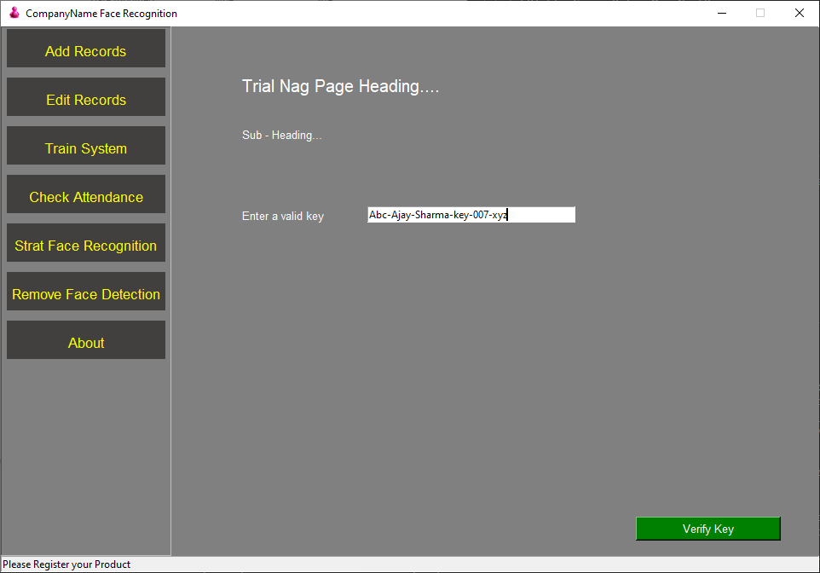

**Note – Without verifying the login process , the user cannot move to any tab/ button**

* After successfully verifying the key on server – it Registers New User on local machine

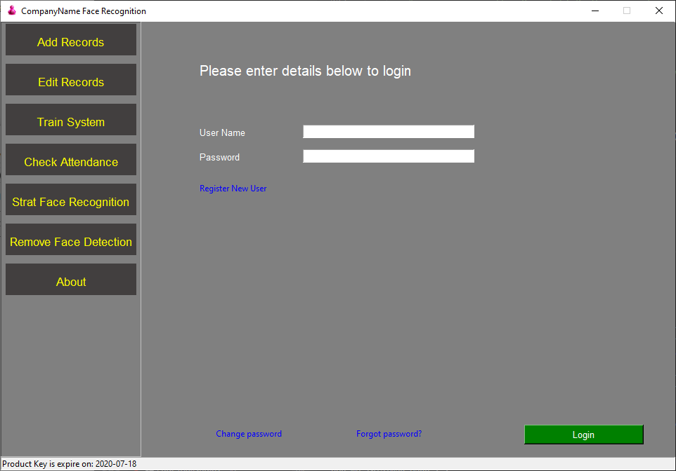

If a user tries to login without registering first, then she/he is not allowed to do so .

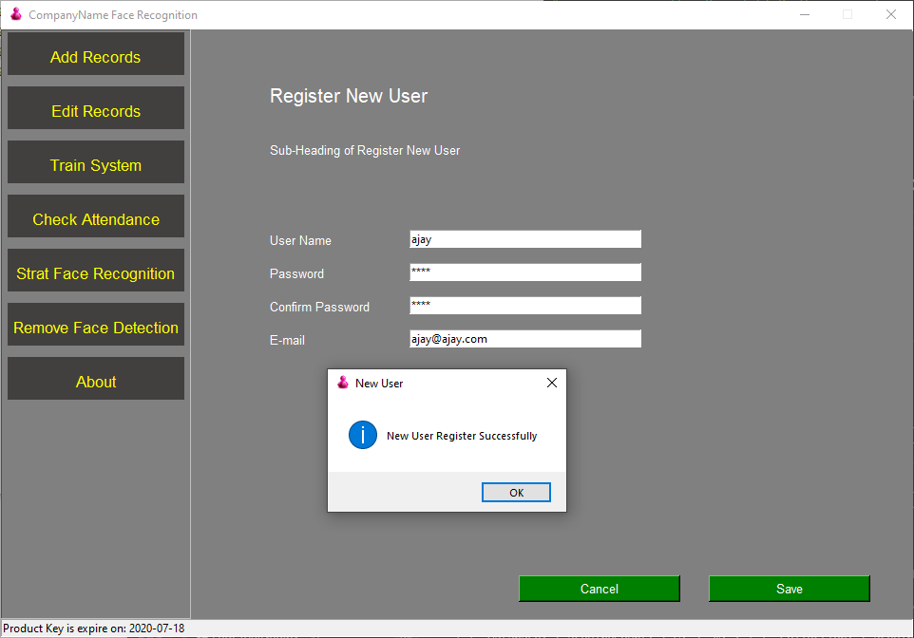

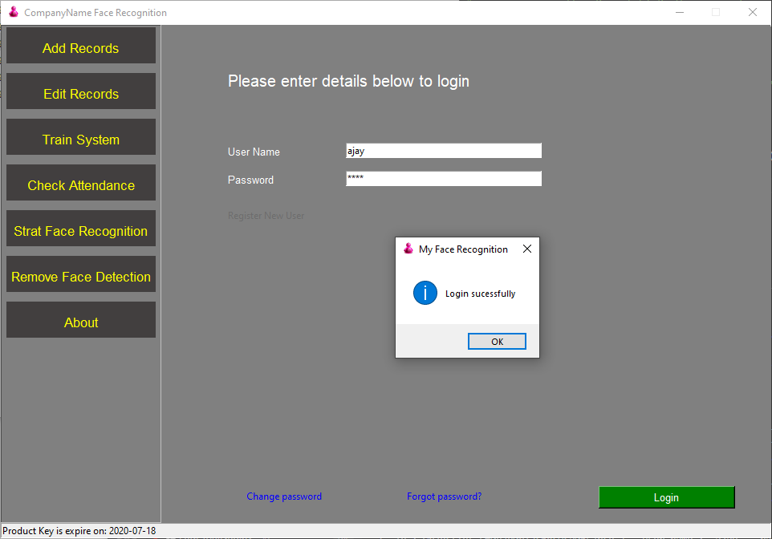

* There is an option to change the old password.

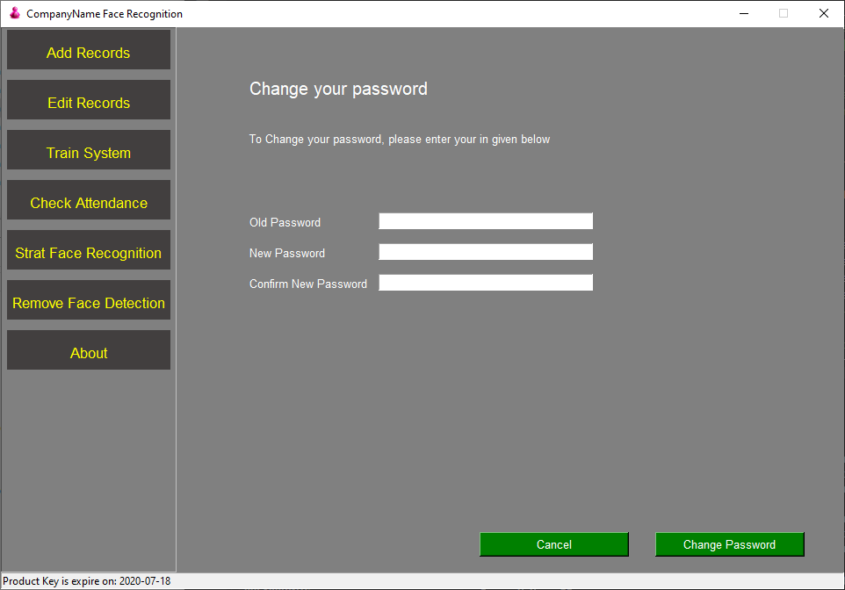

* Add New Record - If the user tries to enter text in place of mobile number then a validation check is done on email id. etc

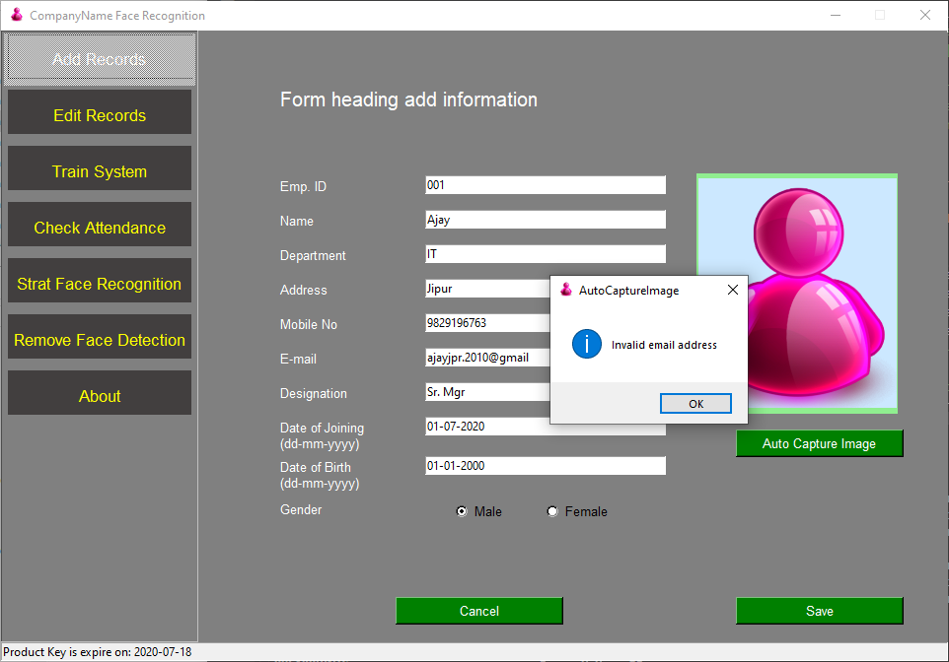

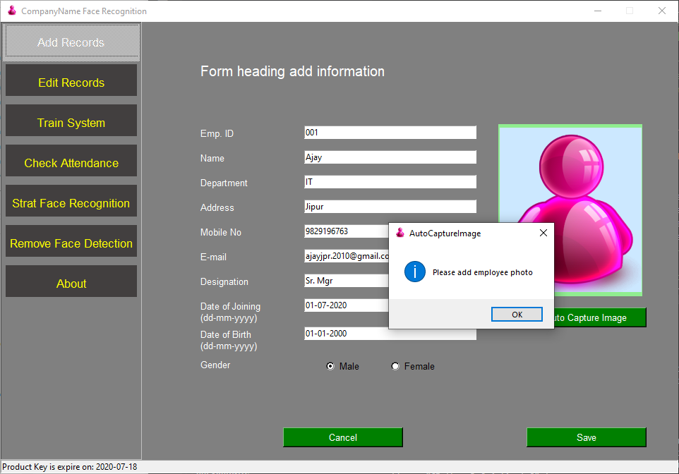

* Steps – Auto capturing an image

**Note – Be careful during the image capturing process, follow the instructions given below -**

1. **Proper light on face during image capture**
2. **Always face should come in center of given face circle**
3. **Always take few face image from LEFT, RIGHT, UP, DOWN – Slightly tilted position as both eyes and nose properly seining in the image**
4. **Do not panic or hurry during this process as all these images are going to our system training process, so you are requested to take neat and clear photos,**
5. **Use always good quality camera for image processing**
6. **Please open “staffImages” and cross check all captured images and if any image is dull or not clear or both eyes not clear, or face is not properly captured than delete all these images BEFORE system training**

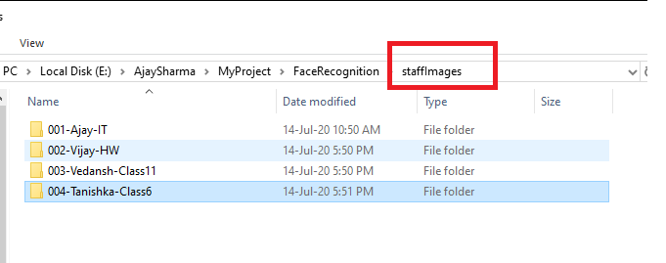

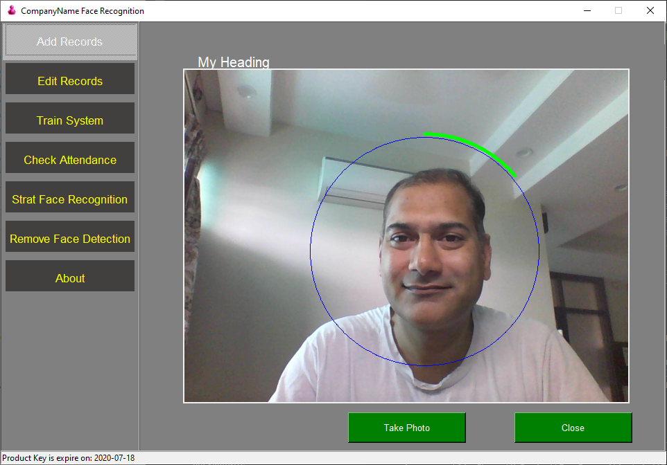

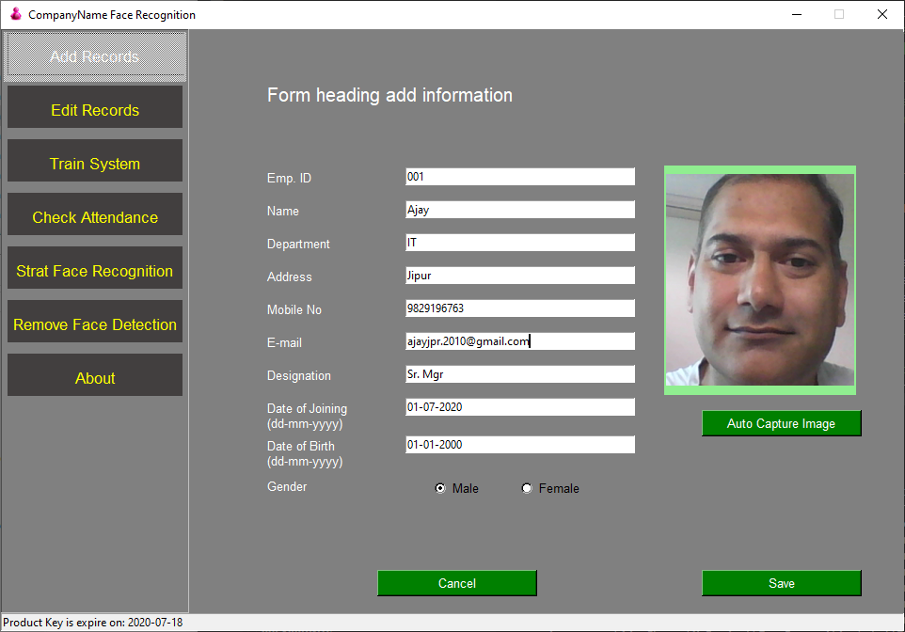

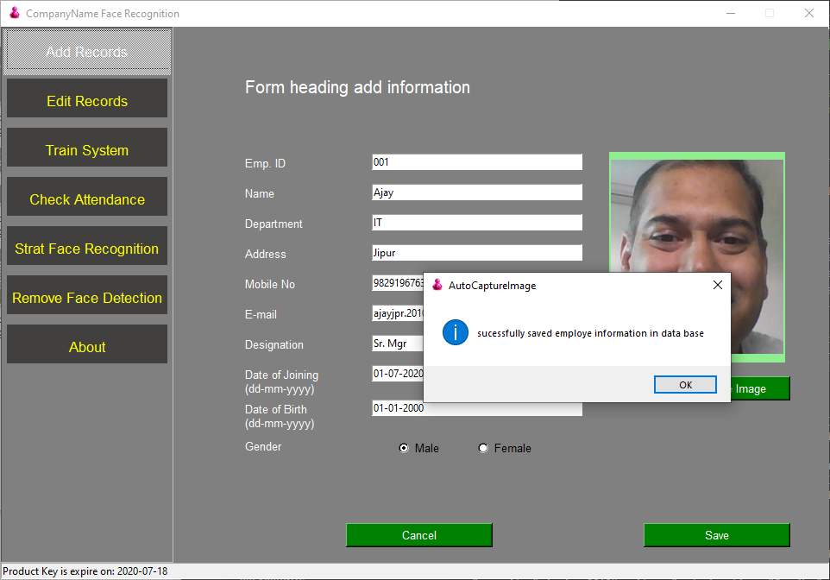

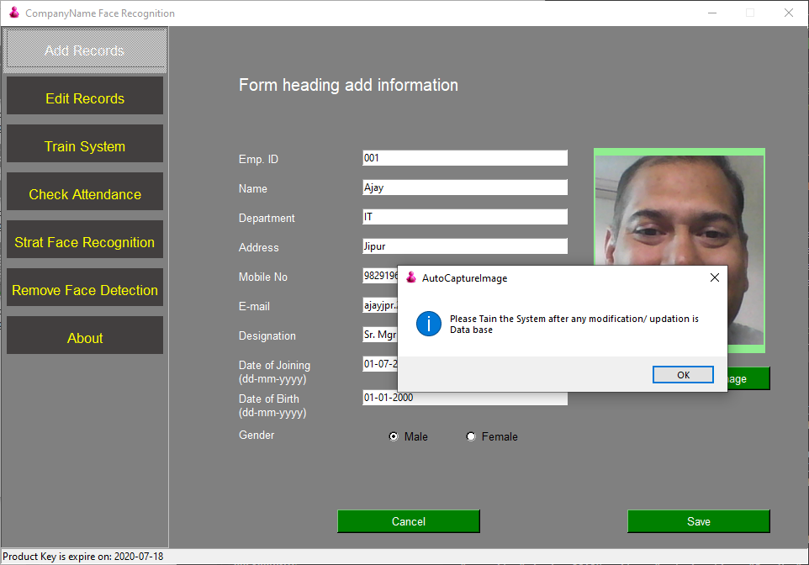

* for editing and update any false records

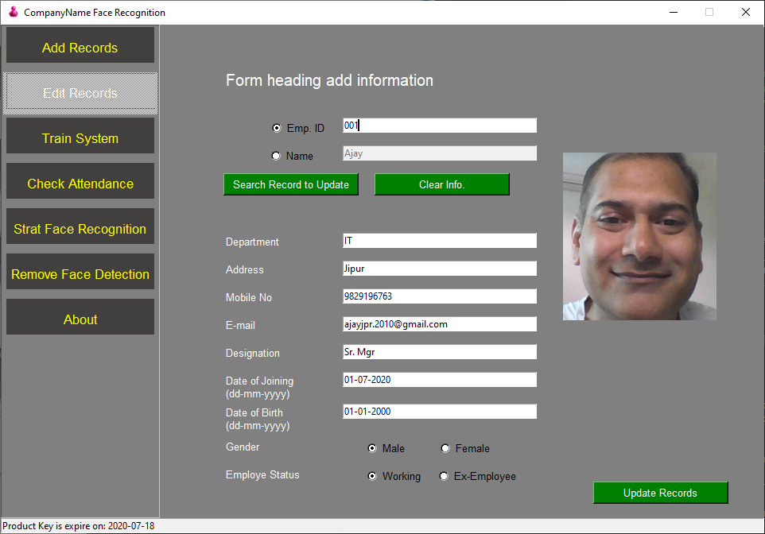

* Tain the system as per capture images

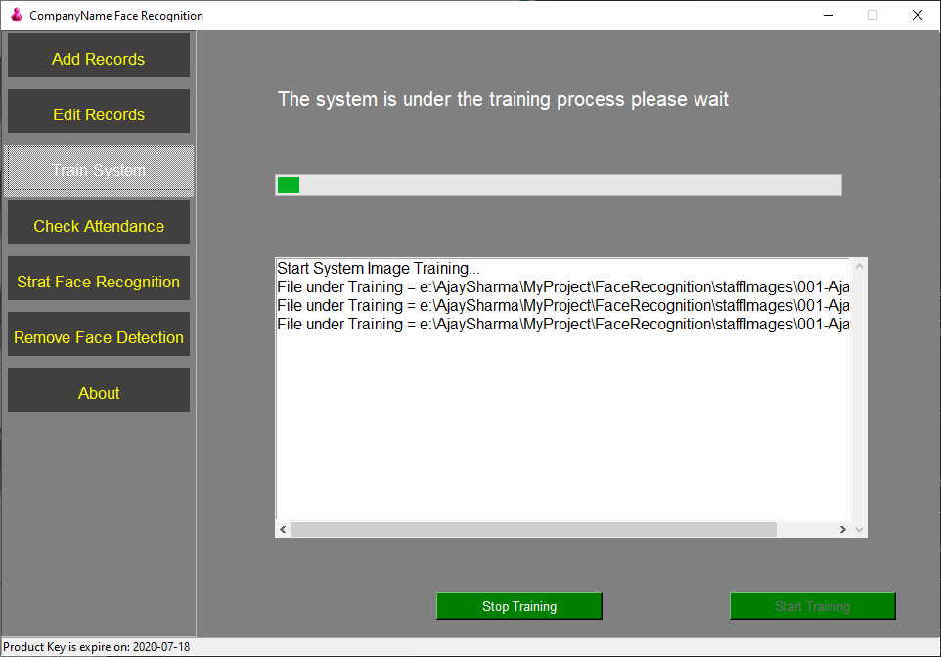

* **If error message comes after training then delete all those images from given path and again train the system until all images are properly processed**

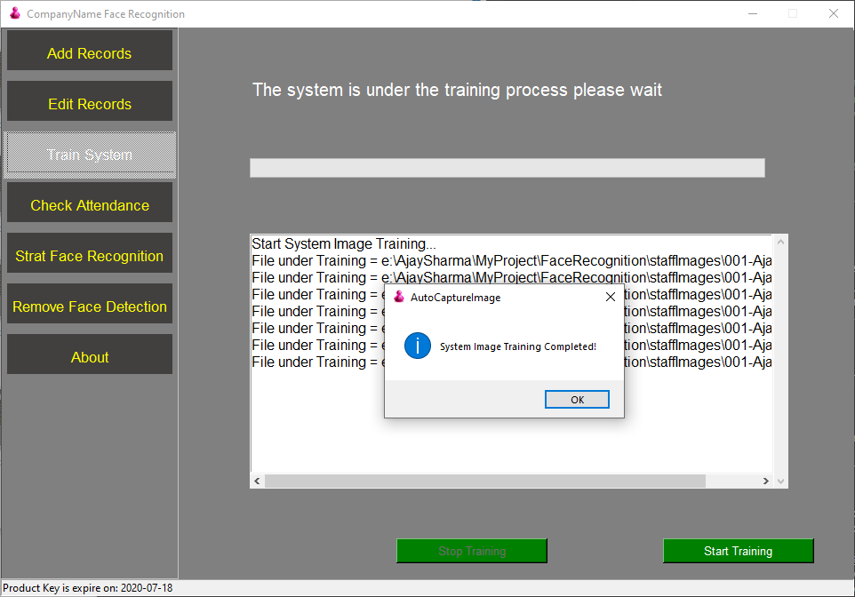

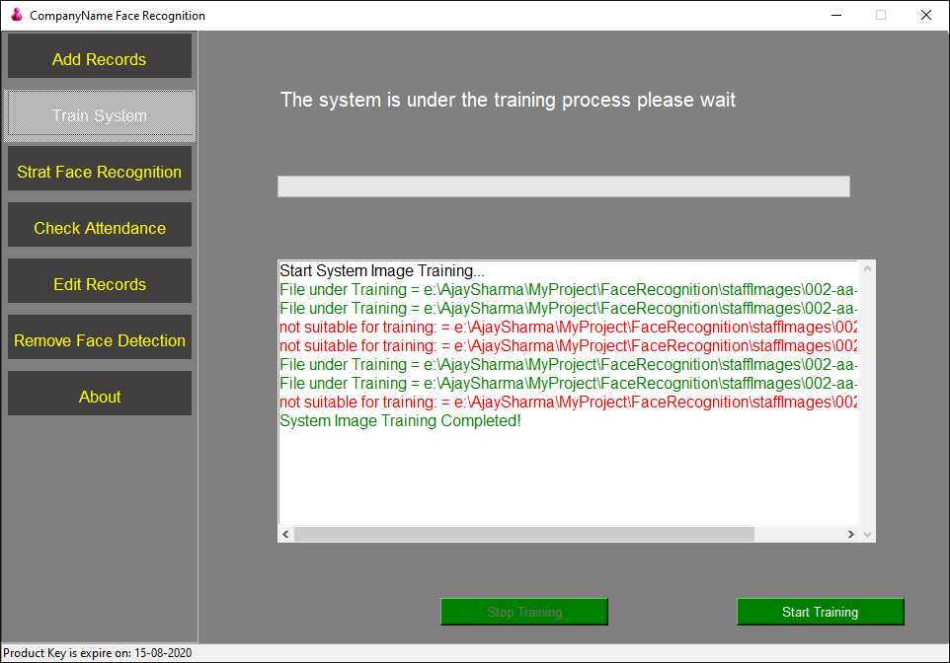

**Below images are not suitable for system training as the coordinates of face are not in proper manner**

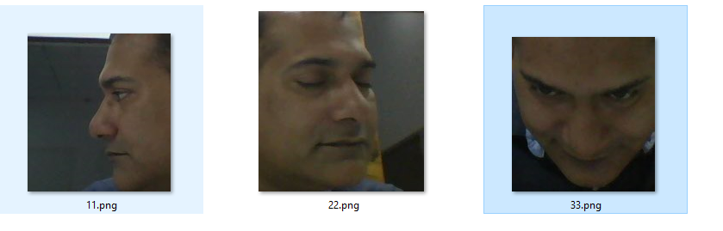

**Below images are the good for system training as face coordinates are in proper manner**

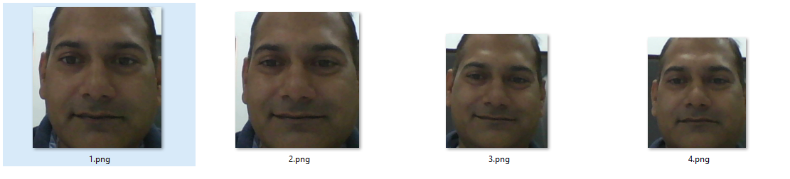

**- START our face recognition process**

- Green Rectangle after attendance mark

- Red Rectangle for Unknown person

- Beep sound means your attendance is marked

- Blue rectangle around the face means more than one face in camera

- and if more than one face appears in camera , then attendance is not marked

- proper lighting on face for quickly recognizing the face

- Attendance will be marked again, after 15 second of time span for already marked employee, if the employee is still there

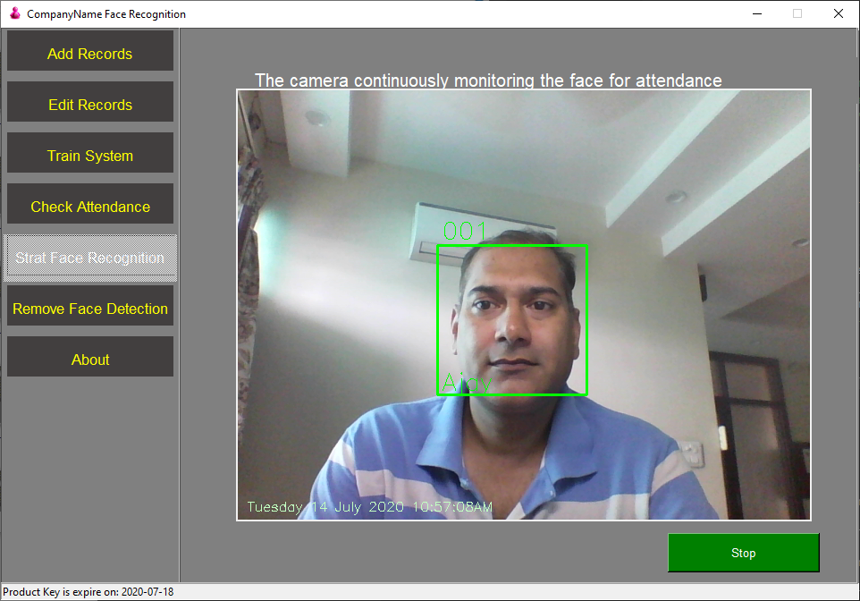

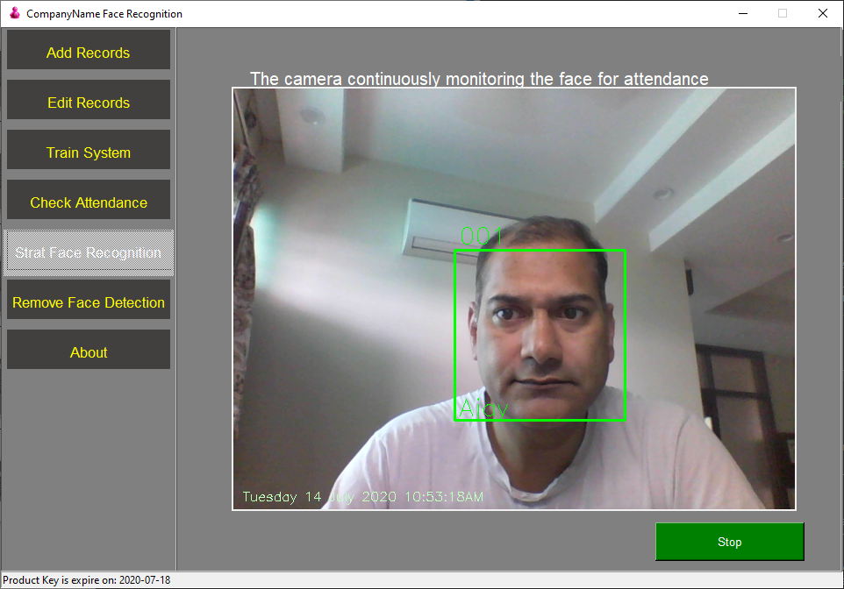

- If you want to move to another tab first you have to stop the running camera process

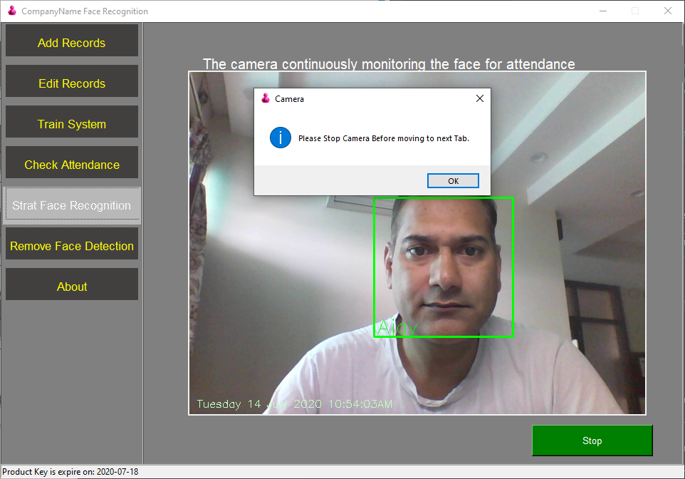

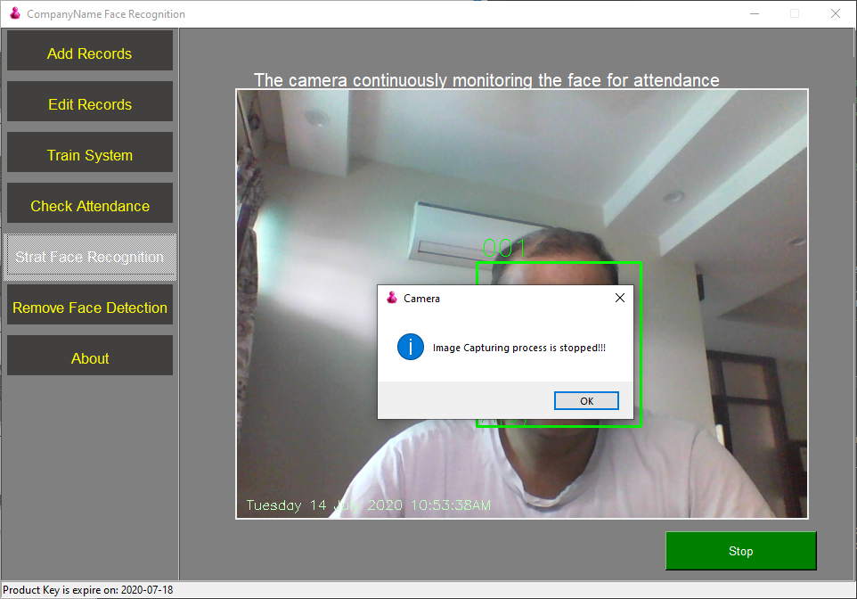

* Check Attendance mark

After search if user exists than the Original photo will be displayed.

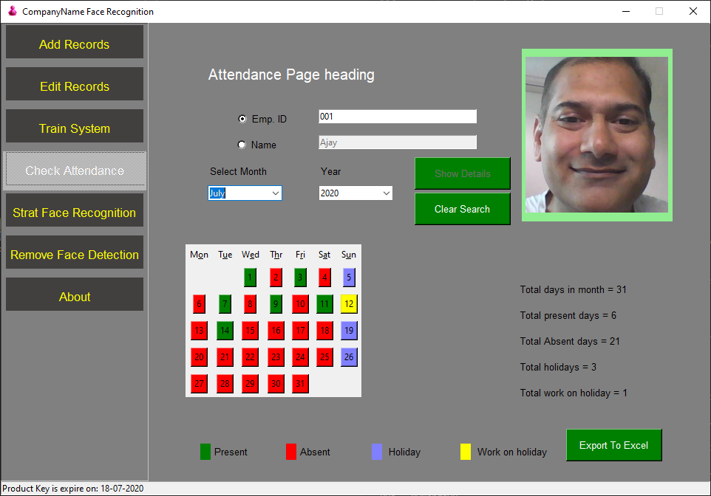

* If you click on green button of calendar than it display attendance marked photo of that Day

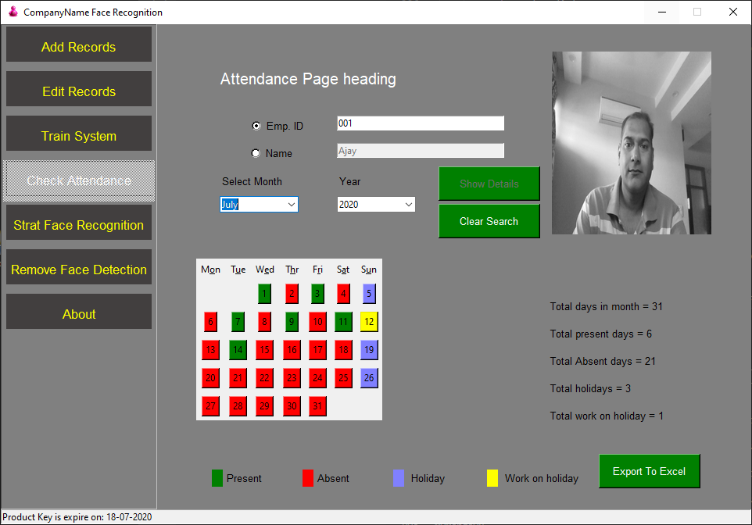

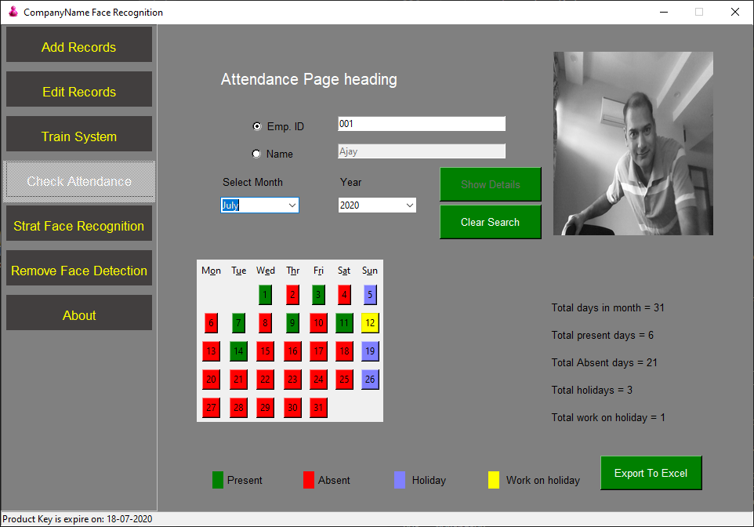

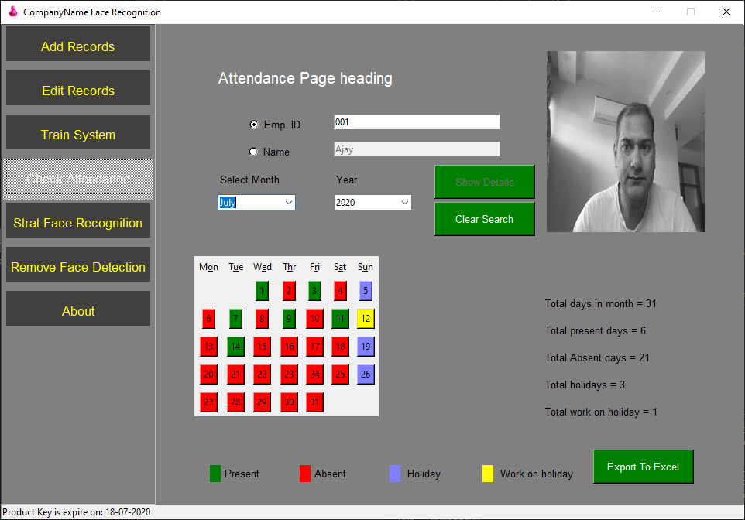

Export attendance data into excel

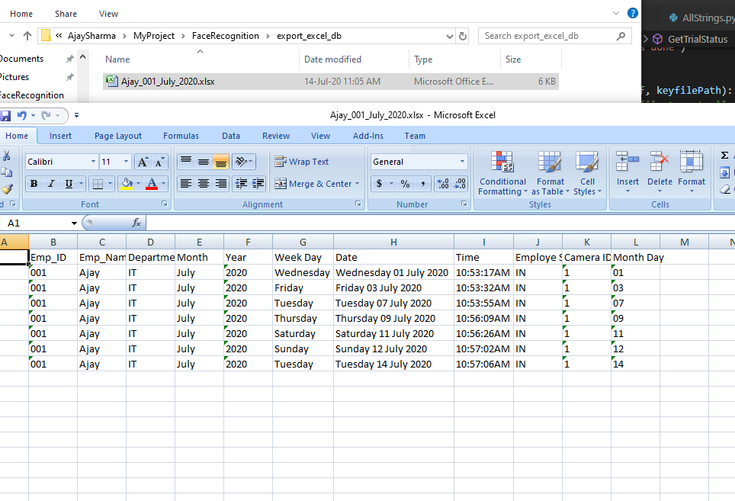

* If Employee leaves the job and we don’t want that our system still recognizes his/ her face, So we can easily remove from here and after **that Start System training**

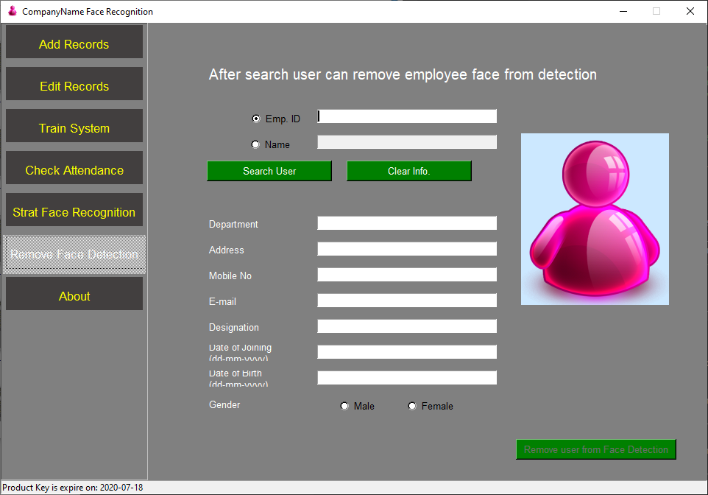

* About

